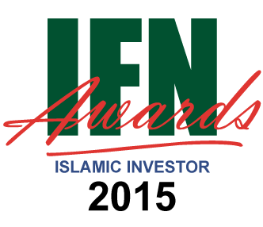
Category Nominated | For example: Most Innovative Asset Management Company
Firm Name:
Address:
Main Contact Name:
Designation:
Telephone Number:
Email:
Date of Submission:
Head of Department
Number of Fund Managers in this department:
Total AUM, Total Shariah compliant AUM and AUM annual % growth 2013-14

Total number of Shariah compliant funds under management
(Note any new launches in the last 12 months)
List of Islamic funds / mandates under this category (mark ‘Confidential’ where required)

Short synopsis on your chosen category (max 250 words)

Short synopsis on the past 12 months’ activities in this category (max 500 words)
Any further information you feel may assist in your case (max 250 words)
For each relevant fund – please include all the following information where applicable
Name of Fund: | For example: Al Isthimar Balanced Fund
Fund Manager
Number of Analysts
Fund Type
Objective
Asset Class/Theme/Sector Focus
Launch Date
Asset Allocation / Weighting
Fund Size
Assets Under Management (AUM)
Net Asset Value (NAV)
% Growth
Annual & YTD Returns Performance again Benchmark

Please email your submission to Andrew.Morgan@REDmoneygroup.com before the end of the 23rd October 2015

